Mini Project Report On

PERSONALIZED LEARNING PLATFORM
Submitted in partial fulfillment of the requirements for the award of the degree of

BACHELOR OF TECHNOLOGY
In

COMPUTER SCIENCE AND ENGINEERING

Submitted By:

K.RISHITHA 23UP1A0532

Project Coordinator
Mrs. B.Ramya
Assistant Professor

DEPARTMENT OF COMPUTER SCIENCE AND ENGINEERING

VIGNAN’S INSTITUTE OF MANAGEMENT AND TECHNOLOGY FOR WOMEN
(Affiliated to JNTUH, Hyderabad, Accredited by NBA)

Kondapur(v), Ghatkesar(M), Medchal -Malkajgiri(D) -501301 [2023 -2027]

DEPARTMENT OF COMPUTER SCIENCE AND ENGINEERING

CERTIFICATE

This is to certify that the Project work titled “Personalized learning platform” submitted by K.RISHITHA ( 23UP1A0532 ) of B -Tech in the partial fulfillment of the requirements for the award of the degree of Bachelor of Technology in Computer Science and Engineering to the Vignan’s Institute of Management and Technology for Women is a record of bona -fide work carried out by them under my guidance and supervision. The results embodied in this project report have not been submitted to any university for the award of any degree and the results are achieved satisfactorily.

Project Coordinator HEAD OF THE DEPARTMENT

Mrs.B.RAMYA SRI Mrs.M.PARIMALA
(Assistant Professor) (Associate Professor)

(External Examiner)

DECLARATION

I, hereby declare that the results embodied in this dissertation entitled “Personalized learning platform” is carried out by us during the year 2023 -2024 in partial fulfillment of the award of Bachelor of Technology in Computer Science and Engineering from VIGNAN’S INSTITUTE OF MANAGEMENT AND TECHNOLOGY FOR WOMEN is an authentic record of our work carried under the guidance of Mrs.B.Ramya Sri(Assistant Professor), Department of Computer Science and Engineering. We have not submitted the same to any other university or organization for the award of any other degree.

K.RISHITHA(23UP1A0532)

ACKNOWLEDGEMENT

We would like to express sincere gratitude to Dr. G. AppaRao Naidu, Principal, Vignan’s Institute of Management and Technology for Women for his timely suggestions which helped us to complete the project in time.

We would also like to thank our madam Mrs. M Parimala, Head of the Department, Computer Science and Engineering, for providing us with constant encouragement and resources which helped us to complete the project in time.

We would like to thank our project guide, Mrs. B.Ramya Sri, Assistant Professor, Computer Science and Engineering, for his timely cooperation and valuable suggestions throughout the project. We are indebted to his for the opportunity given to work under his guidance.

Our sincere thanks to all the teaching and non -teaching staff of the Department of Computer Science and Engineering for their support throughout our project work.

K.RISHITHA(23UP1A0532)

Abstract

The education landscape is undergoing a significant transformation with the integration of technology-driven solutions. A Personalized Learning Platform (PLP) is an innovative approach that tailors educational experiences to individual learners based on their strengths, weaknesses, learning styles, and preferences. Unlike traditional one-size-fits-all educational models, PLP utilizes Artificial Intelligence (AI), Machine Learning (ML), and Data Analytics to provide customized learning paths, real-time feedback, and interactive content to enhance knowledge retention and engagement.The key components of a PLP include an adaptive learning engine, content recommendation system, real-time performance tracking, and intelligent assessment mechanisms. The platform continuously evaluates the learner's progress and dynamically adjusts content difficulty and instructional methods to optimize learning outcomes. Additionally, gamification, virtual simulations, and peer collaboration features make learning more engaging and effective.One of the primary advantages of PLP is its ability to cater to diverse learners, including students, professionals, and individuals with special needs. By leveraging AI-driven analytics, the system identifies knowledge gaps and more inclusive. provides personalized study plans, ensuring efficient time utilization and improved learning efficiency. Furthermore, integrating natural language processing (NLP) and voice assistants enhances accessibility, making education

INDEX
CONTENTS PAGENO

1 | Introduction | 9
1.2 | Proposed System | 10
2 | System Requirements | 11
2.1 | Hardware Requirement | 11
2.2 | Software Requirement | 12
3 | System Design | 12
3.1 | System Architecture | 12
3.2 | Methodologies | 13
4 | UML Diagrams | 14
4.1 | Use Case Diagram | 15
4.2 | Activity Diagram | 16
4.3 | Class Diagram | 17
5 | Software Environment | 18
5.1 | Website | 18
5.2 | Working | 18
5.3 | Security | 20
5.4 | Advantages | 21
5.5 | Disadvantages | 22
6 | Implementation | 23
7 | Code | 24
8 | Result | 52
9 | Conclusion | 55
10 | Future Scope/Enhancement | 56

LIST OF FIGURES

Fig No | Name | PageNo
4.1 | System Architecture
5.1 | Use Case Diagram
5.2 | Activity Diagram
5.3 | Class Diagram
7.1 | Working of Hash
9.1 | Home Page
9.2 | Manufacturer Registration page
9.3 | Manufacturer Login Page
9.4 | Manufacturer Page
9.5 | Saving Products to Blockchain
9.6 | Retrieving Products
9.7 | User Page
9.8 | Authenticate Product QR Code
9.9 | Product Details
9.10 | Output Page

INTRODUCTION

In the evolving landscape of education, traditional one-size-fits-all teaching methods are increasingly giving way to more learner-centric approaches. One of the most transformative innovations in this space is the Personalized Learning Platform—a technology-driven solution designed to adapt to individual learning needs, preferences, and paces. This project focuses on building such a platform that places the learner at the heart of the educational experience, promoting not just knowledge acquisition but also active participation, self-motivation, and continuous improvement.The primary goal of a personalized learning platform is to empower students to take charge of their own learning journey. By leveraging artificial intelligence, machine learning algorithms, and data analytics, the system can tailor learning paths based on each student's strengths, weaknesses, interests, and progress. This ensures that every learner receives the right content, in the right format, at the right time.Our platform integrates a rich variety of multimedia content, including video lectures, interactive e-books, real-time quizzes, simulations, and gamified exercises. This approach caters to different learning styles—visual, auditory, reading/writing, and kinesthetic—enhancing both engagement and retention.In addition to content delivery, the platform is built to foster independent learning and critical thinking. Features such as adaptive quizzes, real-time progress tracking, and AI-generated study plans provide students with regular feedback and allow them to set and monitor personal learning goals. These tools not only support academic achievement but also help students develop self-awareness and lifelong learning habits.Furthermore, the platform includes collaborative tools like virtual classrooms, discussion forums, and peer-to-peer activities to build a sense of community and shared learning. This social aspect helps in developing communication skills, teamwork, and problem-solving capabilities.
In summary, this Personalized Learning Platform aims to redefine digital education by delivering a customized, interactive, and inclusive learning experience that adapts to the unique needs of each learner. It supports both formal and informal learning, making it an ideal solution for schools, colleges, training institutes, and self-learners alike.

1.2 PROPOSED SYSTEM

The proposed system is a Personalized Learning Platform that aims to revolutionize the educational experience by offering a flexible, adaptive, and learner-centric environment. Unlike traditional learning systems that provide the same content and pace for all students, this platform intelligently adjusts learning paths based on individual performance, preferences, and goals. It is designed to support students, educators, and institutions by delivering customized educational content and tools to foster better learning outcomes. Using AI and data analytics, the platform tracks student progress, offers adaptive quizzes, and generates personalized study plans. It supports students in self-paced learning while enabling teachers to monitor performance and provide feedback. Collaboration is encouraged through discussion forums and virtual classrooms, fostering a sense of community among learners.

Advantages
• Personalized Learning Experience: Adapts content and learning paths based on individual student needs, pace, and style.
• Improved Engagement: Uses multimedia content and gamification (badges, points, leaderboards) to keep learners motivated and active.
• Enhanced Learning Outcomes: Adaptive quizzes and study plans help reinforce understanding and improve retention.
• Real-Time Progress Tracking: Students and teachers can monitor learning progress and performance with visual dashboards.
• Teacher Support: Educators can track student activity, provide feedback, and adjust instruction accordingly.
• Anytime, Anywhere Learning: Accessible across devices (mobile and web), supporting remote and self-paced learning.
• Collaborative Environment: Discussion forums and virtual classrooms encourage peer learning and communication.
• Scalable and Flexible: Suitable for various educational institutions, from schools to training centers and online learning platforms.

2. SYSTEM REQUIREMENTS

2.1 Hardware Requirements:
- Development Machines
      - Processor : Quad -core or higher (Intel i7 orequivalent AMD).
      - RAM : 16GB or higher.
      - Storage : SSD with atleast 512GB.
      - Graphics : Dedicacted graphic cards
- Servers
- Web Server: -
- Processor : Multi -core(Intel Xeon or AMD EPYC).
- RAM : 32GB or higher.
- Storage : SSD with RAID configuration for redundancy,starting at 1TB.
- Network : High speed network interface (1Gbps or higher).
- Database server : -
- Processor : Multi -core (Intel Xeon or AMD EPYC).
- RAM : 64GB or higher.
- Storage : SSD with RAID configuration for redundancy, starting at 2TB.
- Network : High speed network interface (1Gbps or higher).
- Backup and Storage
- Processor : Multi -core.
- RAM : 16GB.
- Storage : High -capacity HDDs with RAID configuration, starting at 4TB.
- NAS or cloud storage for off -site backups.
2.2 Software Requirements:
- Development Environment : -
- Operating system : Windows.
- Code Editor/IDE : Visual Studio Code.
- Verwsion Control : Git with GitHub, GitLab, or Bitbucketfor responsibility management.
- Front -end Development : -
- Languages : HTML, CSS, JavaScript.
- Frameworks/Libraries : React.js, Angular, or Vue.js.
- CSS Preprocessors : SASS or LESS.
- Build Tools : Webpack, Babel, Gulp.
- Package Managers : nps or Yam.
- Back -end Development : -
- Languages : Javascript (Node.js)
- Frameworks : Express.js (for Node.js)
- API Development : RESTful API, GraphQL (optional).
- Database Management :-MYSQL

3. SYSTEM DESIGN

3.1 SYSTEM ARCHITECTURE

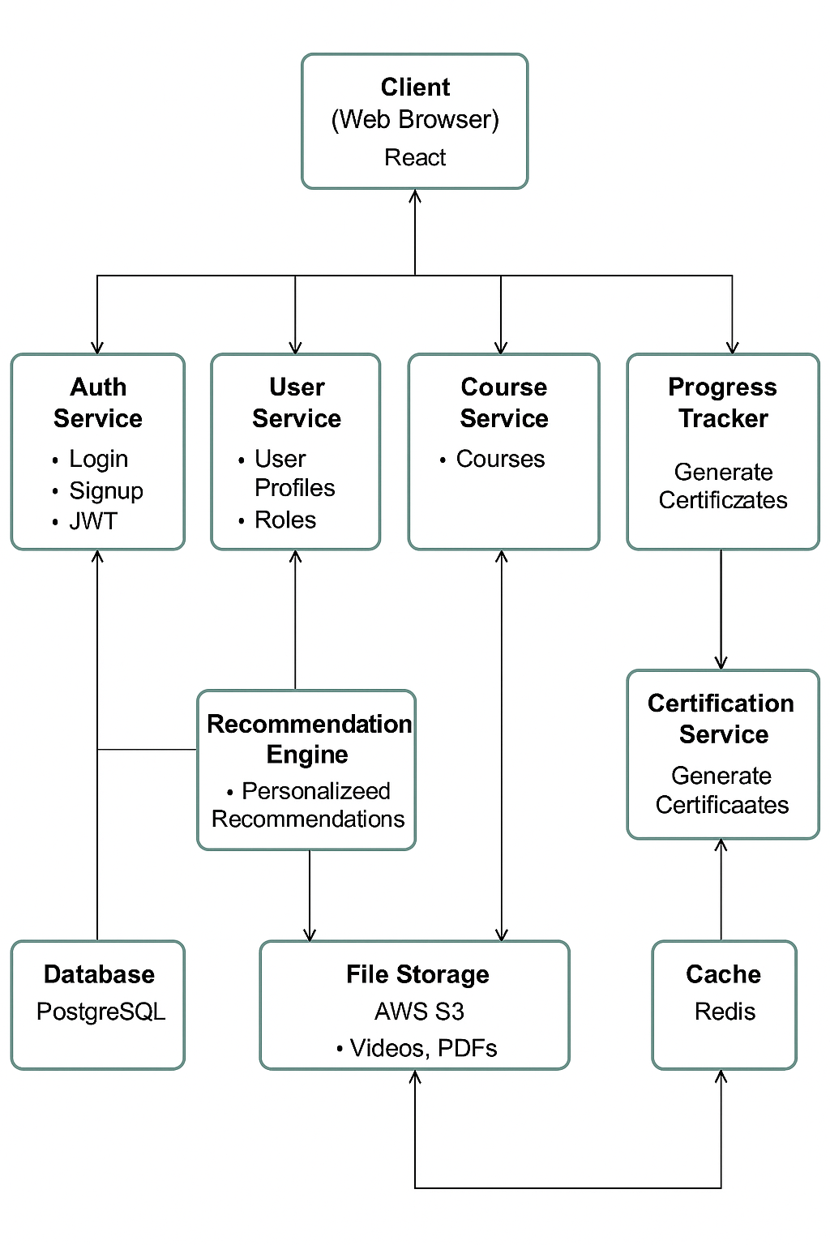

Fig 3.1 : -System Architecture

3.2 Methodologies:
Developing a Personalized Learning Platform involves applying a combination of educational, technical, and user-focused methodologies. These ensure that the system is adaptive, secure, scalable, and engaging for diverse learners. Here are seven key methodologies adopted in the project:

1.Agile Software Development Lifecycle (SDLC):
The platform is developed using Agile methodology, enabling iterative progress through sprints.This allows continuous user feedback, quick enhancements, and faster adaptation to changing educational needs.
2.User-Centered Design (UCD):
A learner-first approach is applied during the design phase. Through user personas, feedback and usability testing, the interface is made intuitive and accessible to accommodate different learning styles and levels.
3.AI-Driven Personalization:
Machine learning algorithms are used to analyze user behavior and performance to recommend personalized study plans, adjust content difficulty, and deliver relevant learning materials, enhancing learner engagement and outcomes.
4.Modular Content Management:
Content is managed in a modular format—video lectures, quizzes, e-books, and simulations—which allows easy updates, tagging by difficulty and subject, and flexible reuse across courses.
5.Secure User Management and Access Control:
Multi-role user access is implemented (students, teachers, admins), with properauth entication and authorization mechanisms. Sensitive data and user interactions are protected through encryption and access control policies.
6.Collaborative Learning Environment:
Features like discussion forums, peer assessments, and virtual classrooms are incorporated to promote communication, teamwork, and a sense of community among learners and educators.
7.Continuous Integration and Maintenance:
The system is deployed using CI/CD pipelines, allowing smooth updates, bug fixes, and feature enhancements. Regular performance monitoring ensures platform stability and scalability as user traffic grows.

4. UML DIAGRAMS

The UML Use Case Diagram for the Personalized Learning Platform identifies four main actors: Student, Instructor, Administrator, and System (AI Engine). The Student can register, log in, browse and enroll in courses, view course content (videos, PDFs), track their progress, take assessments, earn certificates, and give feedback. The Instructor uploads course materials, manages student enrollments, and monitors learner progress. The Administrator approves courses, manages users, and ensures the platform is maintained properly. The System (AI Engine) plays a vital role by recommending personalized courses based on user behavior and generating certificates after course completion. Each use case is represented with ovals connected to actors using association lines. The diagram effectively captures user-system interactions, making it easier to understand system functionality from a user-centric view.

4.1 USE CASE DIAGRAM

The UML Use Case Diagram models the key interactions between users and the system. Four main actors are involved: Student, Instructor, Administrator, and the AI System. Students can register, enroll in courses, view content, track progress, take quizzes, and receive certificates. Instructors manage course materials and monitor learner progress. Administrators handle user and course approvals. The AI System recommends personalized courses and issues certificates. This diagram provides a clear overview of functional requirements from the user's perspective.

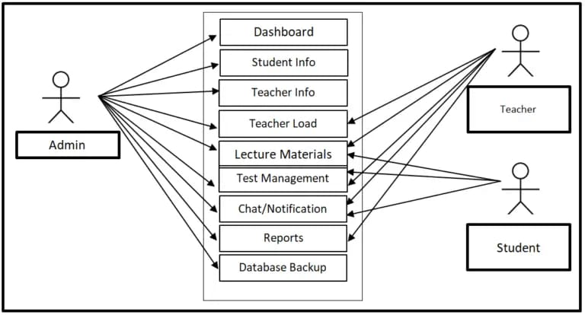
Fig 5.1: Use Case Diagram

4.2 ACTIVITY DIAGRAM

The UML Activity Diagram outlines the workflow of a student's learning journey. It begins with user login, followed by browsing and enrolling in courses. Students then access learning materials, track progress, and take quizzes. Upon successful completion, a certificate is generated. The diagram shows decision points and parallel activities, ensuring a smooth learning process flow.

Fig 4.2 : Activity diagram

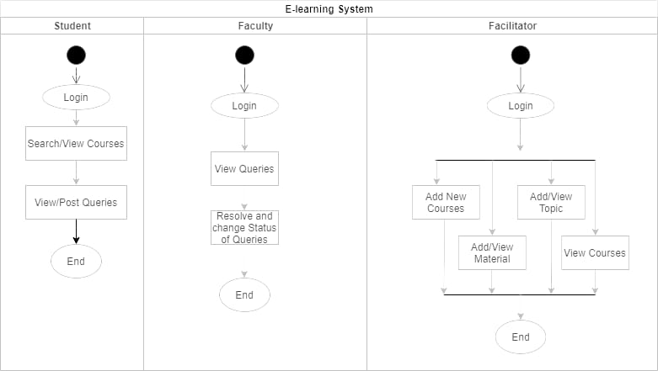
4.3 CLASS DIAGRAM

A class diagram in UML (Unified Modeling Language) is a visual representation of the structure and relationships within a system. It depicts classes, their attributes, methods, and the associations between them. Class diagrams are crucial for understanding the architecture of a system, facilitating communication among stakeholders, and guiding the implementation process in software development. They provide a blueprint for developers to design and implement software systems effectively

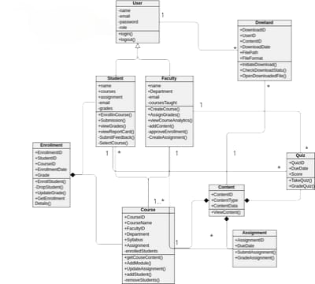

Fig 4.3 : Class diagram

5. SOFTWARE ENVIRONMENT

5.1 WHAT IS A PERSONALIZED LEARNING PLATFORM?
A personalized learning platform is an online educational system designed to deliver customized learning experiences to students based on their individual needs, preferences, and learning pace. It enables learners to access educational content, assignments, quizzes, and interactive activities tailored to their unique abilities and interests, often powered by algorithms that adapt content delivery dynamically.
This platform typically features an intuitive user interface, a vast catalog of learning materials such as videos, articles, and exercises, as well as progress tracking tools. It may also include social features like discussion forums and peer collaboration tools. For educators, the platform provides tools to create and manage courses, monitor student progress, and offer targeted interventions.
For learners, personalized learning platforms offer the flexibility to study anytime and anywhere, allowing them to focus on areas where they need improvement and advance more quickly in subjects they grasp well. By analyzing learning data, the platform continuously adjusts content and difficulty to optimize educational outcomes.
With advancements in technology, personalized learning platforms now incorporate AI-driven recommendations, gamification, and integration with other educational tools to enhance engagement and effectiveness, revolutionizing how education is delivered and experienced globally.

5.2 WORKING OF PERSONALIZED LEARNING PLATFORM
A personalized learning platform functions as an interactive digital environment where learning content and experiences are customized and delivered electronically via the internet. Here’s a detailed overview of how it works:
I.User Interface and Experience:
1.Frontend Design: The platform offers a user-friendly interface tailored for easy navigation by students and educators, including dashboards displaying course progress and personalized recommendations.
2.Content Library: Educational content is organized by subjects, levels, and topics, enriched with multimedia such as videos, readings, quizzes, and interactive simulations.
3.Adaptive Learning Paths: The system provides customized learning paths by analyzing student performance and preferences to recommend appropriate content and difficulty levels.
4.Assessment Tools: Quizzes, assignments, and tests are available to evaluate learner understanding and adapt the next steps accordingly.
5.Progress Tracking: Learners can view their progress, achievements, and areas for improvement through real-time dashboards and reports.

II.Backend Operations:
1.Database Management: Stores user profiles, learning materials, assessment results, and analytics data securely.
2.Content Management System (CMS): Allows educators to upload, organize, and update learning resources and assessments.
3.Learning Analytics: Collects and processes data on learner interactions, performance, and engagement to enable personalization and progress monitoring.
4Adaptive Algorithms: Use machine learning models to adjust content difficulty and recommend resources based on learner data and feedback.
5.Security: Implements encryption and secure authentication mechanisms to protect user data and maintain privacy.
III.Integration with Third-party Services:
1.Video Conferencing: Integration with platforms like Zoom or Microsoft Teams for live classes and virtual office hours.
2.Payment Gateways: If offering premium courses, integrates secure payment processors for subscriptions or one-time fees.
3.Content Providers: Connects with external educational content providers or open educational resources (OER) to expand learning materials.
4.Communication Tools: Incorporates email, notifications, and messaging services to keep users informed and engaged.
IV.User Account Management and Support:
1.Learner and Educator Accounts: Users can create accounts to personalize their learning experience, save progress, and manage courses.
2.Support Services: Provides helpdesk, FAQs, tutorials, and live chat to assist users with technical issues or learning guidance.
3.Community Features: Forums, discussion boards, and peer collaboration spaces facilitate interaction and knowledge sharing.
V.Analytics and Optimization:
1.Data Analytics: Tracks usage patterns, engagement levels, assessment scores, and learning outcomes to help educators refine teaching strategies.
2.Personalization Feedback Loop: Continuously refines the adaptive learning algorithms based on learner feedback and performance data.
3.Reporting: Generates detailed reports for students, educators, and administrators to monitor overall platform effectiveness and individual progress.
5.3 SECURITY
Securing a personalized learning platform with strong security measures is essential to protect user data, maintain privacy, and ensure a safe and trustworthy learning environment. Below is an overview of typical security systems implemented in such platforms:
1.HTTPS and SSL/TLS Encryption:
1.Purpose: Encrypts all communication between the user’s browser and the platform’s web server to ensure confidentiality and data integrity.
2.Implementation: Obtain and install SSL/TLS certificates to enable HTTPS across all pages, especially where users input sensitive data such as login credentials, personal profiles, and payment information.
2.Secure Authentication and Authorization:
1.Purpose: Ensures that only legitimate users (learners, educators, and administrators) can access protected resources and perform authorized actions.
2.Strong Password Policies: Enforce the use of complex passwords and encourage or require periodic password changes.
3.Multi-Factor Authentication (MFA): Add an extra verification step during login to increase account security.
4.Role-Based Access Control (RBAC): Define different user roles and restrict access to platform features and data according to user permissions.
3.Data Privacy and Protection:
1.Purpose: Safeguards sensitive learner and educator information such as personal details, academic records, and assessment results.
3.Data Encryption: Encrypt sensitive data both at rest (in databases) and in transit using strong encryption standards like AES-256.
4.Anonymization: When applicable, anonymize user data used for analytics to protect user identity.
1.Compliance: Adhere to relevant data protection regulations such as GDPR, FERPA, or COPPA, depending on the user demographics and geography.
5.Secure Payment Processing (If applicable):
1.Purpose: Protects financial transactions for paid courses or subscriptions from fraud and unauthorized access.
Implementation:
1.PCI DSS Compliance: Follow Payment Card Industry Data Security Standards for handling payment data securely.
2.Tokenization: Use tokens instead of storing raw payment data to minimize exposure risks.
6.Regular Security Audits and Vulnerability Assessments:
1.Purpose: Detects security weaknesses proactively to prevent breaches and data leaks.
Implementation:
2.Perform regular penetration testing and vulnerability scans on the platform.
3.Conduct code reviews and security audits.
4.Promptly patch identified vulnerabilities and update dependencies and libraries to the latest secure versions.
7.User Activity Monitoring and Anomaly Detection:
Purpose: Identifies suspicious behavior to prevent misuse or attacks such as account takeovers or cheating during assessments.
Implementation:
1.Monitor login attempts, unusual activity patterns, and concurrent sessions.
2.Implement alerts and automated responses to suspicious events.
8.Backup and Disaster Recovery:
Purpose: Ensures that user data and educational content are protected against accidental loss or ransomware attacks.
Implementation:
1.Maintain regular encrypted backups of all critical data.
Test disaster recovery procedures to guarantee quick restoration of service.

5.4 ADVANTAGES
Implementing a strong security framework in a personalized learning platform offers numerous benefits that are essential for learners, educators, and the platform provider. Here are seven key advantages:
1.Protection of User Data:
Robust security measures such as encryption and strict access controls ensure that sensitive learner and educator information—like personal details, academic records, and progress data—is securely stored and transmitted.
2.Prevention of Unauthorized Access and Academic Misconduct:
Advanced authentication protocols and monitoring tools help prevent unauthorized account access, cheating during assessments, and misuse of the platform.
3.Secure Payment Processing (if applicable):
Secure payment gateways and compliance with industry standards (such as PCI DSS) protect users' financial information during course enrollments or subscription payments.
4.Compliance with Data Privacy Regulations:
Adhering to legal frameworks such as GDPR, FERPA, or COPPA ensures that the platform respects user privacy and handles data responsibly, fostering trust and avoiding legal penalties.
5.Enhanced User Trust and Engagement:
When learners and educators are confident that their data and interactions are secure, they are more likely to engage actively, contribute, and continue using the platform.
5.5 DISADVANTAGES
While implementing robust security measures in a personalized learning platform is essential for protecting user data and maintaining trust, there are several potential disadvantages to consider:
1.Complexity and Cost:
Designing, implementing, and maintaining strong security protocols can be complex and expensive, requiring specialized knowledge and ongoing investment.
2.Impact on User Experience:
Stringent security steps like multi-factor authentication or frequent password changes may frustrate users and create barriers to seamless access, potentially affecting learner engagement.
3.False Positives and Access Issues:
Security systems designed to detect suspicious activity might sometimes block legitimate users or flag normal behaviors as threats, causing inconvenience and delays.
4.Regulatory Compliance Burden:
Adhering to multiple privacy and data protection regulations (e.g., GDPR, FERPA, COPPA) demands significant effort in policy management, documentation, and system updates.
5.Performance Overhead:
Encryption, monitoring, and security checks can introduce latency or reduce platform responsiveness, potentially impacting the learning experience.

6 . IMPLEMENTATION

Implementing a personalized learning platform with strong security and adaptive features using HTML, CSS, JavaScript, and backend technologies involves several important steps to ensure a secure, user-friendly, and effective educational environment. Below is a structured approach for the implementation:

1. Designing the User Interface (UI):
HTML Structure: Build the core structure of web pages using semantic HTML tags to define key components such as course catalogs, dashboards, quizzes, progress reports, and user profiles. Ensure accessibility and SEO best practices are followed.
CSS Styling: Style the platform with CSS, using frameworks like Bootstrap or Tailwind CSS to create a responsive, mobile-friendly, and visually engaging interface. Utilize CSS preprocessors (Sass/LESS) for better maintainability and consistency.
JavaScript Interactivity: Add dynamic and interactive elements such as adaptive content display, drag-and-drop exercises, real-time quiz feedback, and notification systems. Optimize JavaScript for fast loading and security.

2. User Authentication and Authorization:
Secure Login System: Implement secure login forms with client-side validation using JavaScript and server-side verification with backend frameworks (Node.js, Django, Ruby on Rails, etc.).
Role-Based Access Control (RBAC): Define roles such as learners, instructors, and admins with specific permissions to access content, manage courses, or administer the platform.
Session Management: Use secure cookies or JSON Web Tokens (JWT) to manage sessions, ensuring that user authentication state is maintained securely across interactions.

3. Adaptive Learning and Content Delivery:
Personalized Learning Paths: Implement algorithms that analyze learner data and adapt content recommendations and difficulty levels dynamically.
Content Management System (CMS): Develop or integrate a CMS for educators to upload, update, and organize multimedia educational resources and assessments.
Progress Tracking: Design systems to record learner interactions, quiz scores, and progress milestones to tailor subsequent learning material.

4. Data Encryption and Security:
SSL/TLS Encryption: Enable HTTPS across the entire platform to secure data in transit between users and servers.
Database Security: Encrypt sensitive data such as passwords (using bcrypt or Argon2 hashing), personal details, and assessment results. Implement secure access controls and backups for databases.
Input Validation and Sanitization: Protect against injection attacks and XSS by validating and sanitizing inputs both on the client and server sides.

5. Implementing Security Best Practices:
Regular Security Audits: Conduct ongoing security assessments, including penetration testing and code reviews, to identify vulnerabilities.
Multi-Factor Authentication (MFA): Offer MFA to users for an additional security layer during login.
Content Security Policy (CSP): Implement CSP headers to reduce risks of XSS and data injection by controlling trusted sources of executable scripts and content.

6. Backup and Disaster Recovery:
Automated Backups: Schedule regular automated backups of user data, course content, and platform configurations to secure, off-site storage.
Incident Response Plan: Prepare and document procedures to detect, respond to, and recover from security incidents such as data breaches or service outages.

7. User Privacy and Compliance:
Data Privacy Regulations: Ensure compliance with relevant data protection laws (e.g., GDPR, FERPA, COPPA) by providing transparent privacy policies, obtaining explicit user consent for data collection and processing, and allowing users to manage or delete their data.
User Data Management: Implement tools enabling users to view, update, or delete their personal information and control notification preferences.

7. Source Code

HTMLFile Setup
<!DOCTYPE html>
<html lang="en">
<head>
<meta charset="UTF-8">
<meta name="viewport" content="width=device-width, initial-scale=1.0">
<title>EduVerse - Personalized Learning Journey</title>
<link href="https://fonts.googleapis.com/css2?family=Inter:wght@100;200;300;400;500;600;700;800;900&display=swap" rel="stylesheet">
<a href="dashboard.html"></a>
<a href="login.html"></a>
<a href="signup.html"></a>

<style>
:root {
--eduBlue: #3b82f6;
--eduTeal: #14b8a6;
--eduAmber: #f59e0b;
--background: #ffffff;
--foreground: #0f172a;
--muted: #f1f5f9;
--muted-foreground: #64748b;
--border: #e2e8f0;
--input: #e2e8f0;
--ring: #3b82f6;
--radius: 0.75rem;
}

* {
margin: 0;
padding: 0;
box-sizing: border-box;
}

body {
font-family: 'Inter', sans-serif;
background-color: var(--background);
color: var(--foreground);
line-height: 1.5;
}

.container {
width: 100%;
max-width: 1200px;
margin: 0 auto;
padding: 0 1rem;
}

/* Navigation */
.navbar {
position: sticky;
top: 0;
z-index: 40;
width: 100%;
border-bottom: 1px solid var(--border);
background-color: rgba(255, 255, 255, 0.8);
backdrop-filter: blur(8px);
}

.navbar-container {
display: flex;
height: 4rem;
align-items: center;
justify-content: space-between;
}

.navbar-left {
display: flex;
align-items: center;
gap: 1rem;
}

.navbar-brand {
display: flex;
align-items: center;
gap: 0.5rem;
text-decoration: none;
}

.navbar-logo {
color: var(--eduBlue);
}

.navbar-name {
font-size: 1.25rem;
font-weight: 700;
color: var(--foreground);
}

.navbar-name span {
background: linear-gradient(to right, var(--eduBlue), var(--eduTeal));
-webkit-background-clip: text;
background-clip: text;
color: transparent;
}

.navbar-links {
display: none;
gap: 1.5rem;
}

@media (min-width: 768px) {
.navbar-links {
display: flex;
}
}

.navbar-link {
font-size: 0.875rem;
font-weight: 500;
text-decoration: none;
color: var(--foreground);
transition: color 0.2s;
}

.navbar-link:hover {
color: var(--eduBlue);
}

.navbar-search {
display: none;
position: relative;
max-width: 300px;
}

@media (min-width: 768px) {
.navbar-search {
display: flex;
align-items: center;
}
}

.navbar-search-icon {
position: absolute;
left: 0.625rem;
color: var(--muted-foreground);
}

.navbar-search input {
padding: 0.5rem 0.5rem 0.5rem 2rem;
width: 100%;
border-radius: var(--radius);
border: 1px solid var(--input);
background-color: var(--background);
font-size: 0.875rem;
outline: none;
}

.navbar-search input:focus {
border-color: var(--ring);
box-shadow: 0 0 0 2px rgba(59, 130, 246, 0.2);
}

.navbar-auth {
display: flex;
align-items: center;
gap: 1rem;
}

.btn {
display: inline-flex;
align-items: center;
justify-content: center;
font-weight: 500;
text-decoration: none;
border-radius: var(--radius);
transition: all 0.2s;
padding: 0.5rem 1rem;
border: none;
cursor: pointer;
font-size: 0.875rem;
}

.btn-ghost {
background-color: transparent;
color: var(--foreground);
}

.btn-ghost:hover {
background-color: var(--muted);
}

.btn-primary {
background-color: var(--eduBlue);
color: white;
}

.btn-primary:hover {
background-color: rgba(59, 130, 246, 0.9);
}

/* Hero Section */
.hero {
position: relative;
overflow: hidden;
padding: 5rem 0 8rem;
}

.hero-bg-circle-1 {
position: absolute;
top: -10rem;
right: -5rem;
height: 20rem;
width: 20rem;
border-radius: 50%;
background-color: rgba(59, 130, 246, 0.05);
}

.hero-bg-circle-2 {
position: absolute;
bottom: -10rem;
left: -5rem;
height: 20rem;
width: 20rem;
border-radius: 50%;
background-color: rgba(20, 184, 166, 0.05);
}

.hero-grid {
display: grid;
gap: 1.5rem;
align-items: center;
}

@media (min-width: 992px) {
.hero-grid {
grid-template-columns: 1fr 400px;
}
}

@media (min-width: 1200px) {
.hero-grid {
grid-template-columns: 1fr 600px;
}
}

.hero-content {
display: flex;
flex-direction: column;
justify-content: center;
gap: 1rem;
}

.hero-title {
font-size: 2.25rem;
font-weight: 700;
line-height: 1.2;
}

@media (min-width: 640px) {
.hero-title {
font-size: 3rem;
}
}

@media (min-width: 768px) {
.hero-title {
font-size: 3.75rem;
}
}

.hero-title span {
background: linear-gradient(to right, var(--eduBlue), var(--eduTeal));
-webkit-background-clip: text;
background-clip: text;
color: transparent;
}

.hero-description {
color: var(--muted-foreground);
font-size: 1rem;
max-width: 700px;
}

@media (min-width: 768px) {
.hero-description {
font-size: 1.125rem;
}
}

.hero-keyword {
display: inline-block;
min-width: 120px;
font-weight: 600;
color: var(--eduBlue);
}

.hero-cursor {
animation: blink 1s infinite;
}

@keyframes blink {
50% {
opacity: 0;
}
}

.hero-search {
display: flex;
flex-direction: column;
gap: 0.5rem;
margin-top: 1rem;
}

@media (min-width: 400px) {
.hero-search {
flex-direction: row;
}
}

.hero-search-input {
position: relative;
flex: 1;
}

.hero-search-icon {
position: absolute;
left: 0.625rem;
top: 0.625rem;
color: var(--muted-foreground);
}

.hero-search-input input {
padding: 0.5rem 0.5rem 0.5rem 2rem;
width: 100%;
border-radius: var(--radius);
border: 1px solid var(--input);
background-color: var(--background);
font-size: 1rem;
outline: none;
}

.hero-popular {
display: flex;
flex-wrap: wrap;
gap: 0.5rem;
margin-top: 1rem;
font-size: 0.875rem;
color: var(--muted-foreground);
}

.hero-popular a {
text-decoration: none;
color: var(--muted-foreground);
transition: color 0.2s;
}

.hero-popular a:hover {
color: var(--eduBlue);
}

.hero-image {
display: flex;
align-items: center;
justify-content: center;
}

.hero-image-container {
position: relative;
aspect-ratio: 1;
width: 100%;
max-width: 400px;
overflow: hidden;
border-radius: 1rem;
}

.hero-image-container img {
width: 100%;
height: 100%;
object-fit: cover;
}

.hero-image-overlay {
position: absolute;
inset: 0;
background-image: linear-gradient(to top, rgba(0, 0, 0, 0.6), transparent);
}

.hero-image-content {
position: absolute;
bottom: 1.5rem;
left: 1.5rem;
right: 1.5rem;
color: white;
}

.hero-image-label {
font-size: 0.875rem;
font-weight: 500;
}

.hero-image-title {
font-size: 1.5rem;
font-weight: 700;
margin-top: 0.5rem;
}

/* Features Section */
.features {
padding: 6rem 0;
background-color: var(--muted);
}

.features-header {
display: flex;
flex-direction: column;
align-items: center;
justify-content: center;
text-align: center;
margin-bottom: 3rem;
}

.features-title {
font-size: 2.25rem;
font-weight: 700;
margin-bottom: 0.5rem;
}

@media (min-width: 768px) {
.features-title {
font-size: 3rem;
}
}

@media (min-width: 1024px) {
.features-title {
font-size: 3.5rem;
}
}

.features-description {
color: var(--muted-foreground);
max-width: 900px;
font-size: 1rem;
}

@media (min-width: 768px) {
.features-description {
font-size: 1.125rem;
}
}

.features-grid {
display: grid;
grid-template-columns: 1fr;
gap: 1.5rem;
max-width: 1280px;
margin: 0 auto;
}

@media (min-width: 768px) {
.features-grid {
grid-template-columns: repeat(2, 1fr);
gap: 2rem;
}
}

.feature-card {
display: flex;
flex-direction: column;
gap: 0.75rem;
padding: 1.5rem;
border-radius: var(--radius);
border: 1px solid var(--border);
background-color: var(--background);
box-shadow: 0 1px 3px rgba(0, 0, 0, 0.1);
transition: box-shadow 0.3s ease;
}

.feature-card:hover {
box-shadow: 0 4px 6px rgba(0, 0, 0, 0.1);
}

.feature-icon {
display: inline-flex;
align-items: center;
justify-content: center;
width: 3rem;
height: 3rem;
border-radius: 9999px;
background-color: var(--muted);
margin-bottom: 0.5rem;
}

.feature-title {
font-size: 1.25rem;
font-weight: 700;
}

.feature-description {
color: var(--muted-foreground);
}

/* Courses Section */
.courses {
padding: 4rem 0;
}

.courses-header {
display: flex;
flex-direction: column;
align-items: center;
justify-content: space-between;
gap: 1rem;
margin-bottom: 2rem;
}

@media (min-width: 640px) {
.courses-header {
flex-direction: row;
}
}

.courses-title {
font-size: 1.875rem;
font-weight: 700;
}

.course-grid {
display: grid;
grid-template-columns: 1fr;
gap: 1.5rem;
margin-top: 2rem;
}

@media (min-width: 640px) {
.course-grid {
grid-template-columns: repeat(2, 1fr);
}
}

@media (min-width: 768px) {
.course-grid {
grid-template-columns: repeat(3, 1fr);
}
}

@media (min-width: 1024px) {
.course-grid {
grid-template-columns: repeat(4, 1fr);
}
}

.course-card {
position: relative;
overflow: hidden;
border-radius: var(--radius);
border: 1px solid var(--border);
box-shadow: 0 1px 3px rgba(0, 0, 0, 0.1);
transition: transform 0.3s, box-shadow 0.3s;
}

.course-card:hover {
transform: translateY(-4px);
box-shadow: 0 4px 12px rgba(0, 0, 0, 0.15);
}

.course-image {
position: relative;
aspect-ratio: 16 / 9;
}

.course-image img {
width: 100%;
height: 100%;
object-fit: cover;
}

.course-level {
position: absolute;
top: 0.5rem;
right: 0.5rem;
padding: 0.25rem 0.5rem;
font-size: 0.75rem;
font-weight: 500;
border-radius: 9999px;
background-color: rgba(0, 0, 0, 0.6);
color: white;
}

.course-content {
padding: 1rem;
}

.course-category {
display: inline-block;
font-size: 0.75rem;
font-weight: 500;
color: var(--eduBlue);
margin-bottom: 0.5rem;
}

.course-title {
font-size: 1rem;
font-weight: 600;
margin-bottom: 0.5rem;
display: -webkit-box;
-webkit-line-clamp: 2;
-webkit-box-orient: vertical;
overflow: hidden;
}

.course-instructor {
font-size: 0.875rem;
color: var(--muted-foreground);
margin-bottom: 0.5rem;
}

.course-meta {
display: flex;
align-items: center;
gap: 1rem;
font-size: 0.75rem;
color: var(--muted-foreground);
margin-top: 0.5rem;
}

.course-rating {
display: flex;
align-items: center;
}

.course-students {
display: flex;
align-items: center;
}

/* Stats Section */
.stats {
padding: 4rem 0;
background-color: var(--eduBlue);
color: white;
}

.stats-grid {
display: grid;
grid-template-columns: repeat(2, 1fr);
gap: 2rem;
text-align: center;
}

@media (min-width: 640px) {
.stats-grid {
grid-template-columns: repeat(4, 1fr);
}
}

.stat-item {
display: flex;
flex-direction: column;
align-items: center;
}

.stat-value {
font-size: 2.25rem;
font-weight: 700;
}

.stat-label {
font-size: 0.875rem;
opacity: 0.8;
}

/* CTA Section */
.cta {
padding: 6rem 0;
border-top: 1px solid var(--border);
background-color: var(--background);
}

.cta-content {
max-width: 768px;
margin: 0 auto;
text-align: center;
}

.cta-title {
font-size: 1.875rem;
font-weight: 700;
margin-bottom: 1rem;
}

@media (min-width: 640px) {
.cta-title {
font-size: 2.25rem;
}
}

.cta-description {
color: var(--muted-foreground);
margin-bottom: 2rem;
}

.cta-buttons {
display: flex;
gap: 1rem;
justify-content: center;
}

/* Footer */
.footer {
background-color: var(--background);
border-top: 1px solid var(--border);
padding: 3rem 0;
}

.footer-grid {
display: grid;
grid-template-columns: 1fr;
gap: 2rem;
}

@media (min-width: 768px) {
.footer-grid {
grid-template-columns: repeat(2, 1fr);
}
}

@media (min-width: 1024px) {
.footer-grid {
grid-template-columns: repeat(4, 1fr);
}
}

.footer-brand {
margin-bottom: 1rem;
}

.footer-about {
font-size: 0.875rem;
color: var(--muted-foreground);
margin-bottom: 1rem;
}

.footer-socials {
display: flex;
gap: 0.75rem;
}

.footer-social-link {
display: flex;
align-items: center;
justify-content: center;
color: var(--muted-foreground);
transition: color 0.2s;
}

.footer-social-link:hover {
color: var(--eduBlue);
}

.footer-column-title {
font-size: 1.125rem;
font-weight: 600;
margin-bottom: 1rem;
}

.footer-links {
list-style: none;
display: grid;
gap: 0.5rem;
}

.footer-link {
font-size: 0.875rem;
}

.footer-link a {
color: var(--muted-foreground);
text-decoration: none;
transition: color 0.2s;
}

.footer-link a:hover {
color: var(--foreground);
}

.footer-contact-item {
display: flex;
align-items: center;
gap: 0.5rem;
font-size: 0.875rem;
color: var(--muted-foreground);
margin-bottom: 0.5rem;
}

.footer-bottom {
margin-top: 3rem;
padding-top: 1.5rem;
border-top: 1px solid var(--border);
text-align: center;
font-size: 0.875rem;
color: var(--muted-foreground);
}
</style>
</head>
<body>
<!-- Navbar -->
<nav class="navbar">
<div class="container navbar-container">
<div class="navbar-left">
<a href="#" class="navbar-brand">
<svg class="navbar-logo" xmlns="http://www.w3.org/2000/svg" width="24" height="24" viewBox="0 0 24 24" fill="none" stroke="currentColor" stroke-width="2" stroke-linecap="round" stroke-linejoin="round">
<path d="M2 3h6a4 4 0 0 1 4 4v14a3 3 0 0 0-3-3H2z"></path>
<path d="M22 3h-6a4 4 0 0 0-4 4v14a3 3 0 0 1 3-3h7z"></path>
</svg>
<span class="navbar-name">Edu<span>Verse</span></span>
</a>
<div class="navbar-links">
<a href="dashboard.html" class="navbar-link">Home</a>
<a href="dashboard.html" class="navbar-link">Courses</a>
<a href="dashboard.html" class="navbar-link">Dashboard</a>
</div>
</div>

<div class="navbar-search">
<svg class="navbar-search-icon" xmlns="http://www.w3.org/2000/svg" width="20" height="20" viewBox="0 0 24 24" fill="none" stroke="currentColor" stroke-width="2" stroke-linecap="round" stroke-linejoin="round">
<circle cx="11" cy="11" r="8"></circle>
<path d="m21 21-4.3-4.3"></path>
</svg>
<input type="search" placeholder="Search courses...">
</div>

<div class="navbar-auth">
<a href="login.html" class="btn btn-ghost">Log in</a>
<a href="signup.html" class="btn btn-primary">Sign up</a>
</div>
</div>
</nav>

<!-- Hero Section -->
<section class="hero">
<div class="hero-bg-circle-1"></div>
<div class="hero-bg-circle-2"></div>

<div class="container">
<div class="hero-grid">
<div class="hero-content">
<h1 class="hero-title">
Discover Your
<span>Perfect</span>
Learning Path
</h1>
<p class="hero-description">
Personalized courses to master
<span class="hero-keyword">
Programming<span class="hero-cursor">|</span>
</span>
</p>

<div class="hero-search">
<div class="hero-search-input">
<svg class="hero-search-icon" xmlns="http://www.w3.org/2000/svg" width="20" height="20" viewBox="0 0 24 24" fill="none" stroke="currentColor" stroke-width="2" stroke-linecap="round" stroke-linejoin="round">
<circle cx="11" cy="11" r="8"></circle>
<path d="m21 21-4.3-4.3"></path>
</svg>
<input type="search" placeholder="What do you want to learn?">
</div>
<button class="btn btn-primary">Find Courses</button>
</div>

<div class="hero-popular">
<span>Popular:</span>
<a href="#">Web Development</a>
<a href="#">Data Science</a>
<a href="#">Digital Marketing</a>
<a href="#">UX Design</a>
</div>
</div>

<div class="hero-image">
<div class="hero-image-container">
<img src="https://images.unsplash.com/photo-1522202176988-66273c2fd55f?ixlib=rb-4.0.3&ixid=MnwxMjA3fDB8MHxwaG90by1wYWdlfHx8fGVufDB8fHx8&auto=format&fit=crop&w=800&q=80" alt="Students learning together">
<div class="hero-image-overlay"></div>
<div class="hero-image-content">
<div class="hero-image-label">Featured Course</div>
<div class="hero-image-title">Collaborative Learning Techniques</div>
</div>
</div>
</div>
</div>
</div>
</section>

<!-- Features Section -->
<section class="features">
<div class="container">
<div class="features-header">
<h2 class="features-title">Why Choose EduVerse</h2>
<p class="features-description">A modern learning platform designed to help you achieve your goals</p>
</div>

<div class="features-grid">
<div class="feature-card">
<div class="feature-icon">
<svg xmlns="http://www.w3.org/2000/svg" width="24" height="24" viewBox="0 0 24 24" fill="none" stroke="currentColor" stroke-width="2" stroke-linecap="round" stroke-linejoin="round" style="color: #3b82f6;">
<path d="M2 3h6a4 4 0 0 1 4 4v14a3 3 0 0 0-3-3H2z"></path>
<path d="M22 3h-6a4 4 0 0 0-4 4v14a3 3 0 0 1 3-3h7z"></path>
</svg>
</div>
<h3 class="feature-title">Personalized Learning</h3>
<p class="feature-description">Courses tailored to your skill level, learning style and career goals.</p>
</div>

<div class="feature-card">
<div class="feature-icon">
<svg xmlns="http://www.w3.org/2000/svg" width="24" height="24" viewBox="0 0 24 24" fill="none" stroke="currentColor" stroke-width="2" stroke-linecap="round" stroke-linejoin="round" style="color: #14b8a6;">
<circle cx="12" cy="8" r="7"></circle>
<polyline points="8.21 13.89 7 23 12 20 17 23 15.79 13.88"></polyline>
</svg>
</div>
<h3 class="feature-title">Certified Courses</h3>
<p class="feature-description">Earn recognized certificates upon completing your courses.</p>
</div>

<div class="feature-card">
<div class="feature-icon">
<svg xmlns="http://www.w3.org/2000/svg" width="24" height="24" viewBox="0 0 24 24" fill="none" stroke="currentColor" stroke-width="2" stroke-linecap="round" stroke-linejoin="round" style="color: #f59e0b;">
<path d="M16 21v-2a4 4 0 0 0-4-4H6a4 4 0 0 0-4 4v2"></path>
<circle cx="9" cy="7" r="4"></circle>
<path d="M22 21v-2a4 4 0 0 0-3-3.87"></path>
<path d="M16 3.13a4 4 0 0 1 0 7.75"></path>
</svg>
</div>
<h3 class="feature-title">Expert Instructors</h3>
<p class="feature-description">Learn from industry professionals with real-world experience.</p>
</div>

<div class="feature-card">
<div class="feature-icon">
<svg xmlns="http://www.w3.org/2000/svg" width="24" height="24" viewBox="0 0 24 24" fill="none" stroke="currentColor" stroke-width="2" stroke-linecap="round" stroke-linejoin="round" style="color: #3b82f6;">
<line x1="18" y1="20" x2="18" y2="10"></line>
<line x1="12" y1="20" x2="12" y2="4"></line>
<line x1="6" y1="20" x2="6" y2="14"></line>
</svg>
</div>
<h3 class="feature-title">Progress Tracking</h3>
<p class="feature-description">Monitor your learning journey with detailed analytics.</p>
</div>
</div>
</div>
</section>

<!-- Courses Section -->
<section class="courses">
<div class="container">
<div class="courses-header">
<h2 class="courses-title">Recommended for you</h2>
<a href="#" class="btn btn-ghost">View all courses</a>
</div>

<div class="course-grid">
<!-- Course Card 1 -->
<div class="course-card">
<div class="course-image">
<img src="https://images.unsplash.com/photo-1498050108023-c5249f4df085?ixlib=rb-4.0.3&ixid=MnwxMjA3fDB8MHxzZWFyY2h8Mnx8Y29kaW5nfGVufDB8fDB8fA%3D%3D&auto=format&fit=crop&w=500&q=60" alt="Course">
<div class="course-level">Beginner</div>
</div>
<div class="course-content">
<span class="course-category">Programming</span>
<h3 class="course-title">Web Development Fundamentals: HTML, CSS, and JavaScript</h3>
<div class="course-instructor">By John Smith</div>
<div class="course-meta">
<span class="course-rating">4.8 ★</span>
<span class="course-students">1,245 students</span>
</div>
</div>
</div>

<!-- Course Card 2 -->
<div class="course-card">
<div class="course-image">
<img src="https://images.unsplash.com/photo-1551288049-bebda4e38f71?ixlib=rb-4.0.3&ixid=MnwxMjA3fDB8MHxzZWFyY2h8MXx8ZGF0YSUyMHNjaWVuY2V8ZW58MHx8MHx8&auto=format&fit=crop&w=500&q=60" alt="Course">
<div class="course-level">Intermediate</div>
</div>
<div class="course-content">
<span class="course-category">Data Science</span>
<h3 class="course-title">Python for Data Analysis and Visualization</h3>
<div class="course-instructor">By Sarah Johnson</div>
<div class="course-meta">
<span class="course-rating">4.7 ★</span>
<span class="course-students">982 students</span>
</div>
</div>
</div>

<!-- Course Card 3 -->
<div class="course-card">
<div class="course-image">
<img src="https://images.unsplash.com/photo-1561070791-2526d30994b5?ixlib=rb-4.0.3&ixid=MnwxMjA3fDB8MHxzZWFyY2h8M3x8ZGVzaWdufGVufDB8fDB8fA%3D%3D&auto=format&fit=crop&w=500&q=60" alt="Course">
<div class="course-level">Beginner</div>
</div>
<div class="course-content">
<span class="course-category">Design</span>
<h3 class="course-title">UI/UX Design Principles and Best Practices</h3>
<div class="course-instructor">By Emily Chen</div>
<div class="course-meta">
<span class="course-rating">4.9 ★</span>
<span class="course-students">756 students</span>
</div>
</div>
</div>

<!-- Course Card 4 -->
<div class="course-card">
<div class="course-image">
<img src="https://images.unsplash.com/photo-1611926653458-09294b3142bf?ixlib=rb-4.0.3&ixid=MnwxMjA3fDB8MHxzZWFyY2h8NXx8bWFya2V0aW5nfGVufDB8fDB8fA%3D%3D&auto=format&fit=crop&w=500&q=60" alt="Course">
<div class="course-level">Advanced</div>
</div>
<div class="course-content">
<span class="course-category">Marketing</span>
<h3 class="course-title">Digital Marketing Strategy and Social Media</h3>
<div class="course-instructor">By David Wilson</div>
<div class="course-meta">
<span class="course-rating">4.6 ★</span>
<span class="course-students">1,032 students</span>
</div>
</div>
</div>
</div>
</div>
</section>

<!-- Stats Section -->
<section class="stats">
<div class="container">
<div class="stats-grid">
<div class="stat-item">
<div class="stat-value">10K+</div>
<div class="stat-label">Students</div>
</div>
<div class="stat-item">
<div class="stat-value">500+</div>
<div class="stat-label">Courses</div>
</div>
<div class="stat-item">
<div class="stat-value">250+</div>
<div class="stat-label">Instructors</div>
</div>
<div class="stat-item">
<div class="stat-value">15+</div>
<div class="stat-label">Categories</div>
</div>
</div>
</div>
</section>

<!-- Most Popular Courses Section -->
<section class="courses" style="background-color: var(--muted);">
<div class="container">
<div class="courses-header">
<h2 class="courses-title">Most Popular</h2>
<a href="#" class="btn btn-ghost">View all courses</a>
</div>

<div class="course-grid">
<!-- Course Card 1 -->
<div class="course-card">
<div class="course-image">
<img src="https://images.unsplash.com/photo-1526379095098-d400fd0bf935?ixlib=rb-4.0.3&ixid=MnwxMjA3fDB8MHxzZWFyY2h8Mnx8cHl0aG9ufGVufDB8fDB8fA%3D%3D&auto=format&fit=crop&w=500&q=60" alt="Course">
<div class="course-level">All Levels</div>
</div>
<div class="course-content">
<span class="course-category">Programming</span>
<h3 class="course-title">Python Programming: Zero to Hero</h3>
<div class="course-instructor">By Michael Brown</div>
<div class="course-meta">
<span class="course-rating">4.9 ★</span>
<span class="course-students">2,345 students</span>
</div>
</div>
</div>

<!-- Course Card 2 -->
<div class="course-card">
<div class="course-image">
<img src="https://images.unsplash.com/photo-1555949963-ff9fe0c870eb?ixlib=rb-4.0.3&ixid=MnwxMjA3fDB8MHxzZWFyY2h8Mnx8cmVhY3R8ZW58MHx8MHx8&auto=format&fit=crop&w=500&q=60" alt="Course">
<div class="course-level">Intermediate</div>
</div>
<div class="course-content">
<span class="course-category">Programming</span>
<h3 class="course-title">React.js: Building Modern User Interfaces</h3>
<div class="course-instructor">By Jessica Lee</div>
<div class="course-meta">
<span class="course-rating">4.8 ★</span>
<span class="course-students">1,872 students</span>
</div>
</div>
</div>

<!-- Course Card 3 -->
<div class="course-card">
<div class="course-image">
<img src="https://images.unsplash.com/photo-1517245386807-bb43f82c33c4?ixlib=rb-4.0.3&ixid=MnwxMjA3fDB8MHxzZWFyY2h8Mnx8YnVzaW5lc3N8ZW58MHx8MHx8&auto=format&fit=crop&w=500&q=60" alt="Course">
<div class="course-level">Beginner</div>
</div>
<div class="course-content">
<span class="course-category">Business</span>
<h3 class="course-title">Business Strategy and Management Fundamentals</h3>
<div class="course-instructor">By Robert Taylor</div>
<div class="course-meta">
<span class="course-rating">4.7 ★</span>
<span class="course-students">1,456 students</span>
</div>
</div>
</div>

<!-- Course Card 4 -->
<div class="course-card">
<div class="course-image">
<img src="https://images.unsplash.com/photo-1593642533144-3d62aa4783ec?ixlib=rb-4.0.3&ixid=MnwxMjA3fDB8MHxzZWFyY2h8M3x8ZGF0YXxlbnwwfHwwfHw%3D&auto=format&fit=crop&w=500&q=60" alt="Course">
<div class="course-level">Advanced</div>
</div>
<div class="course-content">
<span class="course-category">Data Science</span>
<h3 class="course-title">Machine Learning and Artificial Intelligence</h3>
<div class="course-instructor">By Andrew Clark</div>
<div class="course-meta">
<span class="course-rating">4.9 ★</span>
<span class="course-students">1,982 students</span>
</div>
</div>
</div>
</div>
</div>
</section>

<!-- CTA Section -->
<section class="cta">
<div class="container">
<div class="cta-content">
<h2 class="cta-title">Start your learning journey today</h2>
<p class="cta-description">Join thousands of learners who have already taken the first step towards their goals.</p>
<div class="cta-buttons">
<a href="#" class="btn btn-primary">Get started</a>
<a href="#" class="btn btn-ghost">Explore courses</a>
</div>
</div>
</div>
</section>

<!-- Footer -->
<footer class="footer">
<div class="container">
<div class="footer-grid">
<div>
<div class="footer-brand">
<a href="#" class="navbar-brand">
<svg class="navbar-logo" xmlns="http://www.w3.org/2000/svg" width="24" height="24" viewBox="0 0 24 24" fill="none" stroke="currentColor" stroke-width="2" stroke-linecap="round" stroke-linejoin="round">
<path d="M2 3h6a4 4 0 0 1 4 4v14a3 3 0 0 0-3-3H2z"></path>
<path d="M22 3h-6a4 4 0 0 0-4 4v14a3 3 0 0 1 3-3h7z"></path>
</svg>
<span class="navbar-name">Edu<span>Verse</span></span>
</a>
</div>
<p class="footer-about">
Personalized learning journeys for everyone, anytime, anywhere.
</p>
<div class="footer-socials">
<a href="#" class="footer-social-link">
<svg xmlns="http://www.w3.org/2000/svg" width="20" height="20" viewBox="0 0 24 24" fill="none" stroke="currentColor" stroke-width="2" stroke-linecap="round" stroke-linejoin="round">
<path d="M18 2h-3a5 5 0 0 0-5 5v3H7v4h3v8h4v-8h3l1-4h-4V7a1 1 0 0 1 1-1h3z"></path>
</svg>
<span class="sr-only">Facebook</span>
</a>
<a href="#" class="footer-social-link">
<svg xmlns="http://www.w3.org/2000/svg" width="20" height="20" viewBox="0 0 24 24" fill="none" stroke="currentColor" stroke-width="2" stroke-linecap="round" stroke-linejoin="round">
<rect x="2" y="2" width="20" height="20" rx="5" ry="5"></rect>
<path d="M16 11.37A4 4 0 1 1 12.63 8 4 4 0 0 1 16 11.37z"></path>
<line x1="17.5" y1="6.5" x2="17.51" y2="6.5"></line>
</svg>
<span class="sr-only">Instagram</span>
</a>
<a href="#" class="footer-social-link">
<svg xmlns="http://www.w3.org/2000/svg" width="20" height="20" viewBox="0 0 24 24" fill="none" stroke="currentColor" stroke-width="2" stroke-linecap="round" stroke-linejoin="round">
<path d="M22 4s-.7 2.1-2 3.4c1.6 10-9.4 17.3-18 11.6 2.2.1 4.4-.6 6-2C3 15.5.5 9.6 3 5c2.2 2.6 5.6 4.1 9 4-.9-4.2 4-6.6 7-3.8 1.1 0 3-1.2 3-1.2z"></path>
</svg>
<span class="sr-only">Twitter</span>
</a>
<a href="#" class="footer-social-link">
<svg xmlns="http://www.w3.org/2000/svg" width="20" height="20" viewBox="0 0 24 24" fill="none" stroke="currentColor" stroke-width="2" stroke-linecap="round" stroke-linejoin="round">
<path d="M22.54 6.42a2.78 2.78 0 0 0-1.94-2C18.88 4 12 4 12 4s-6.88 0-8.6.46a2.78 2.78 0 0 0-1.94 2A29 29 0 0 0 1 11.75a29 29 0 0 0 .46 5.33A2.78 2.78 0 0 0 3.4 19c1.72.46 8.6.46 8.6.46s6.88 0 8.6-.46a2.78 2.78 0 0 0 1.94-2 29 29 0 0 0 .46-5.25 29 29 0 0 0-.46-5.33z"></path>
<polygon points="9.75 15.02 15.5 11.75 9.75 8.48 9.75 15.02"></polygon>
</svg>
<span class="sr-only">YouTube</span>
</a>
</div>
</div>

<div>
<h3 class="footer-column-title">Platform</h3>
<ul class="footer-links">
<li class="footer-link"><a href="#">Courses</a></li>
<li class="footer-link"><a href="#">About Us</a></li>
<li class="footer-link"><a href="#">Instructors</a></li>
<li class="footer-link"><a href="#">Pricing</a></li>
</ul>
</div>

<div>
<h3 class="footer-column-title">Resources</h3>
<ul class="footer-links">
<li class="footer-link"><a href="#">Blog</a></li>
<li class="footer-link"><a href="#">FAQ</a></li>
<li class="footer-link"><a href="#">Support</a></li>
<li class="footer-link"><a href="#">Community</a></li>
</ul>
</div>

<div>
<h3 class="footer-column-title">Contact</h3>
<div class="footer-contact-item">
<svg xmlns="http://www.w3.org/2000/svg" width="16" height="16" viewBox="0 0 24 24" fill="none" stroke="currentColor" stroke-width="2" stroke-linecap="round" stroke-linejoin="round">
<path d="M4 4h16c1.1 0 2 .9 2 2v12c0 1.1-.9 2-2 2H4c-1.1 0-2-.9-2-2V6c0-1.1.9-2 2-2z"></path>
<polyline points="22,6 12,13 2,6"></polyline>
</svg>
<a href="mailto:info@eduverse.com">info@eduverse.com</a>
</div>
</div>
</div>

<div class="footer-bottom">
&copy; <script>document.write(new Date().getFullYear())</script> EduVerse. All rights reserved.
</div>
</div>
</footer>

<script>
// Typing animation effect for hero section
const keywords = ["Programming", "Data Science", "Design", "Marketing", "AI", "Business", "Personal Development"];
let currentIndex = 0;
let isDeleting = false;
let text = '';
let typingSpeed = 100;
let deletingSpeed = 50;

function typeEffect() {
const currentKeyword = keywords[currentIndex];

if (isDeleting) {
text = currentKeyword.substring(0, text.length - 1);
} else {
text = currentKeyword.substring(0, text.length + 1);
}

document.querySelector('.hero-keyword').textContent = text;
document.querySelector('.hero-cursor').textContent = '|';

let timing = isDeleting ? deletingSpeed : typingSpeed;

if (!isDeleting && text === currentKeyword) {
timing = 1500; // Pause at the end of word
isDeleting = true;
setTimeout(function() {
typeEffect();
}, timing);
return;
} else if (isDeleting && text === '') {
isDeleting = false;
currentIndex = (currentIndex + 1) % keywords.length;
timing = 500; // Pause before typing next word
}

setTimeout(function() {
typeEffect();
}, timing);
}

// Start the typing animation when the page loads
document.addEventListener('DOMContentLoaded', function() {
setTimeout(typeEffect, 1000);
});
</script>
</body>
</html>

8.RESULTS:

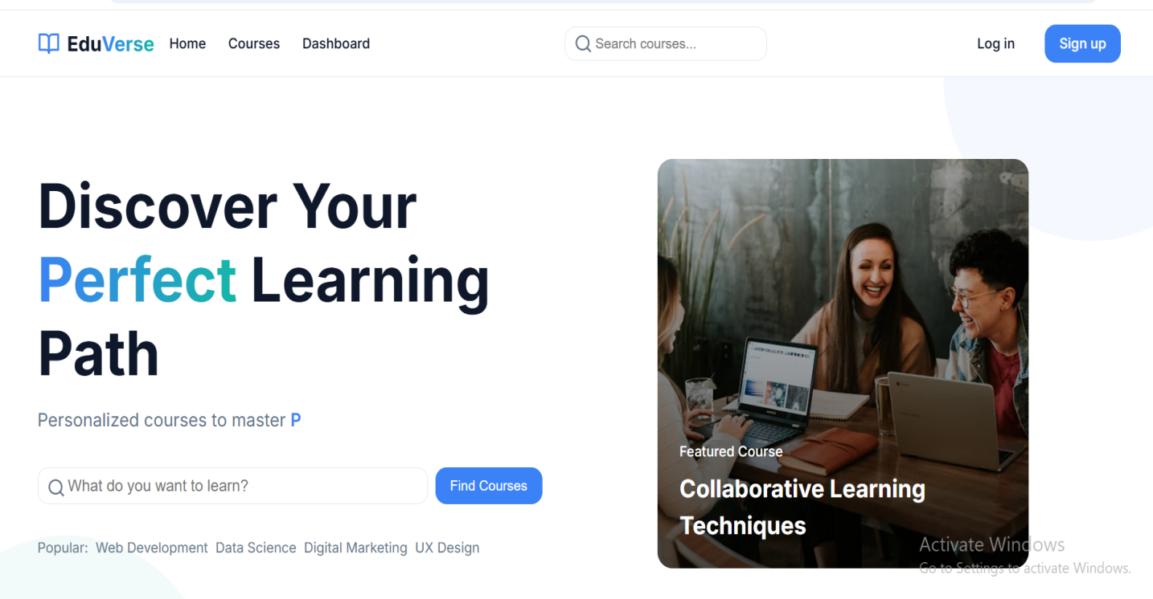

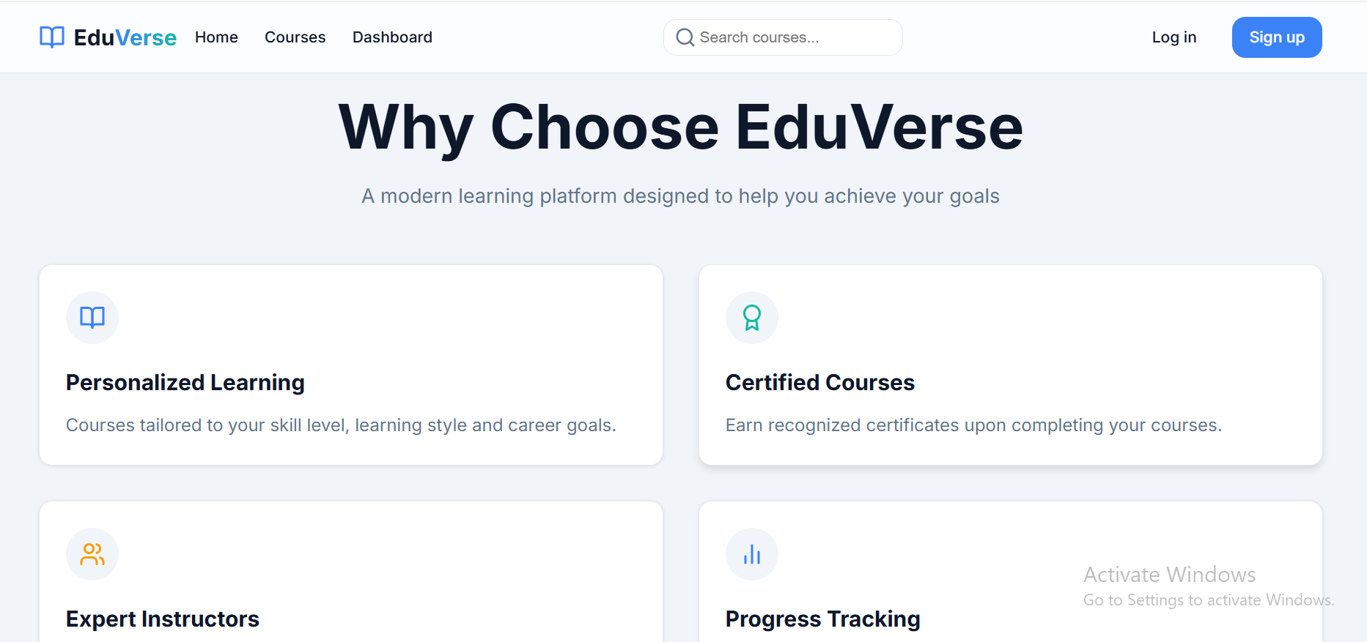

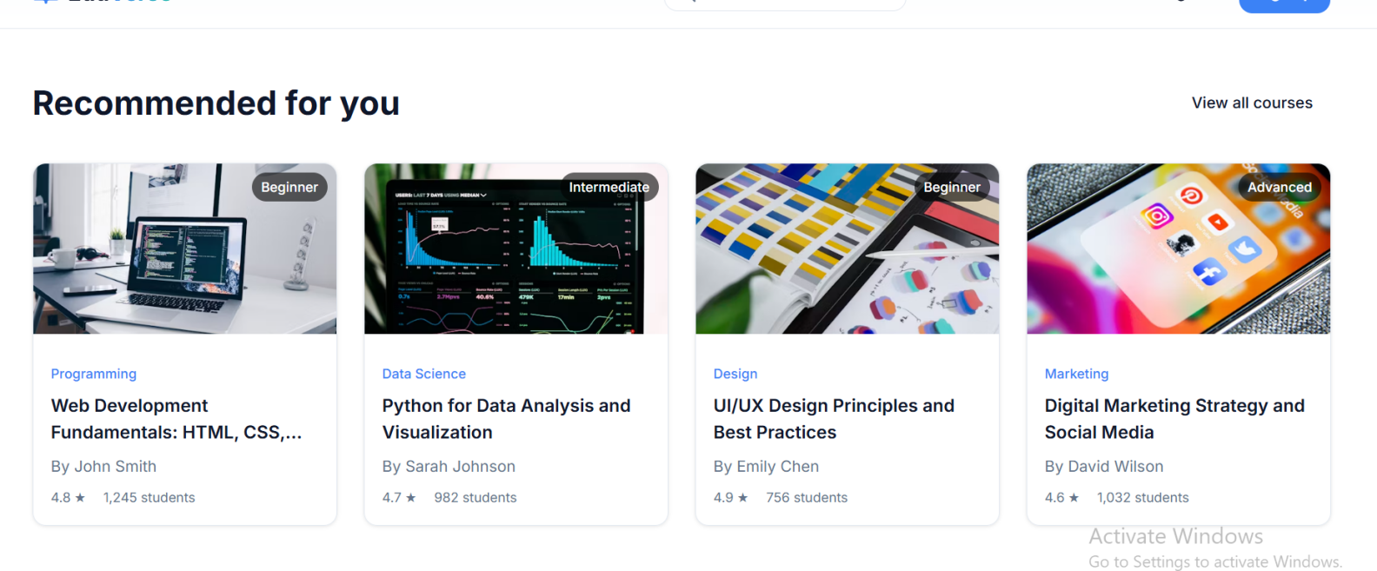

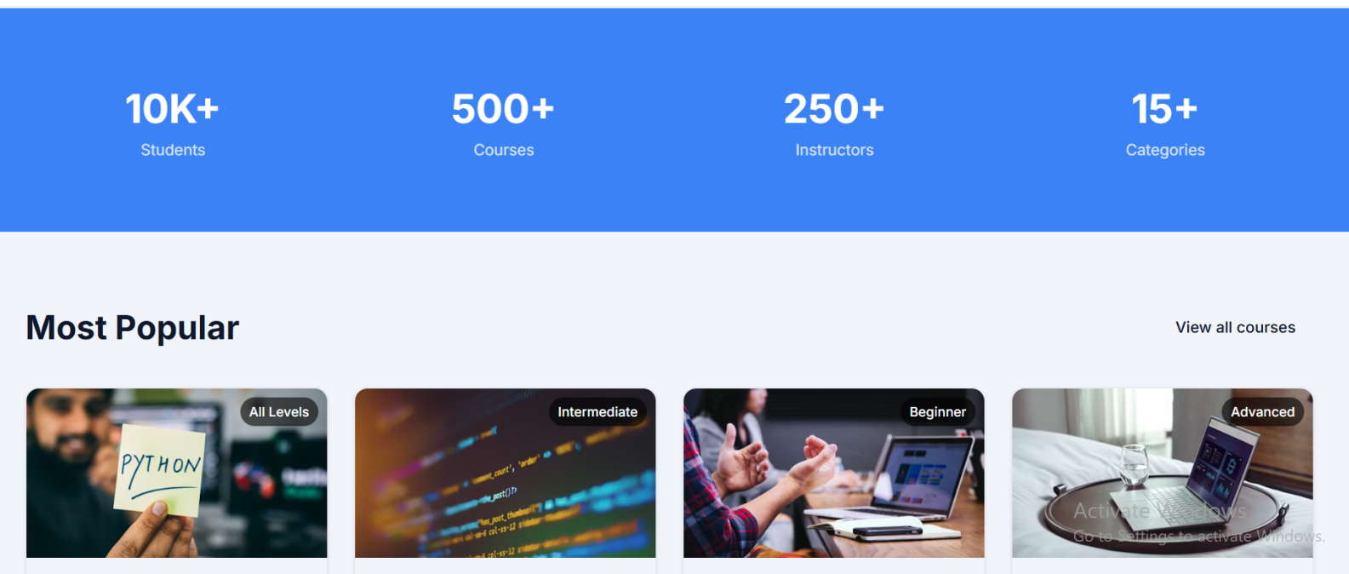
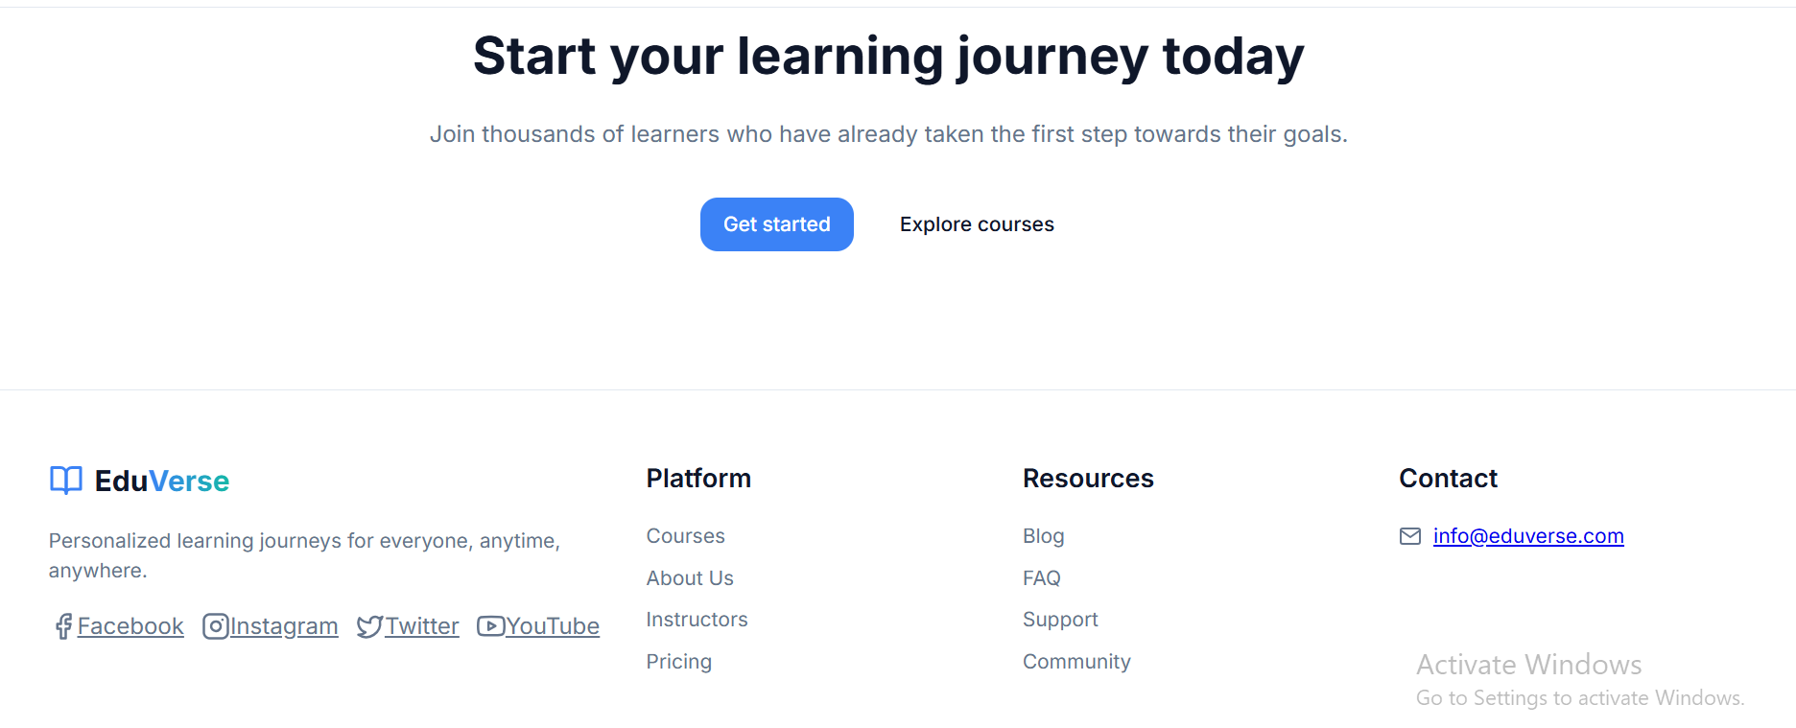

9. CONCLUSION

The development of a Personalized Learning Platform represents a significant step forward in leveraging technology to enhance education. By integrating adaptive learning features, secure user authentication, interactive content delivery, and robust data protection measures, the platform offers a dynamic, user-centric educational environment. It not only supports learners in achieving their academic goals at their own pace but also empowers educators to track performance, tailor instruction, and engage more effectively with students.
The implementation of strong security practices—including data encryption, secure session handling, and compliance with privacy regulations—ensures that user data remains protected and trust is maintained. With the continued evolution of web technologies and data analytics, this platform lays the foundation for scalable, intelligent, and inclusive learning experiences.
Overall, this project demonstrates how a thoughtfully designed personalized learning system can address modern educational needs while ensuring usability, accessibility, and security. It sets the stage for future enhancements such as AI-driven recommendations, gamified learning experiences, and integration with external educational tools and platforms

10. FUTURE SCOPE/ENHANCEMENT

The personalized learning platform has strong potential for future growth and innovation. Some key enhancements include:
1.AI and Machine Learning:Integrate intelligent systems to recommend content, predict learner performance, and offer adaptive learning paths.
2.Mobile App Development:Create mobile versions of the platform to provide learning on-the-go with offline access.
3.Gamification:Add features like badges, points, and leaderboards to increase user engagement and motivation.
4.Multilingual and Accessibility Support:Expand reach by supporting multiple languages and improving accessibility for users with disabilities.
5.Third-Party Integration:Connect with tools like Zoom, Google Classroom, or LMS systems for a more collaborative learning experience.
6.Real-Time Interaction:Include live classes, group discussions, and peer interaction to promote active learning.

